**GIT**

**Handson3 GIT-HOL**

This document demonstrates branching and merging in Git as per Exercise 3. The steps include creating a branch, making changes, committing them, and merging into master.

## Objectives

- Explain branching and merging in Git.  
- Create a branch request in GitLab.  
- Create a merge request in GitLab.

## Step-by-Step Execution

### Step 1: Open the repository

Navigate to the repository folder and verify its contents.

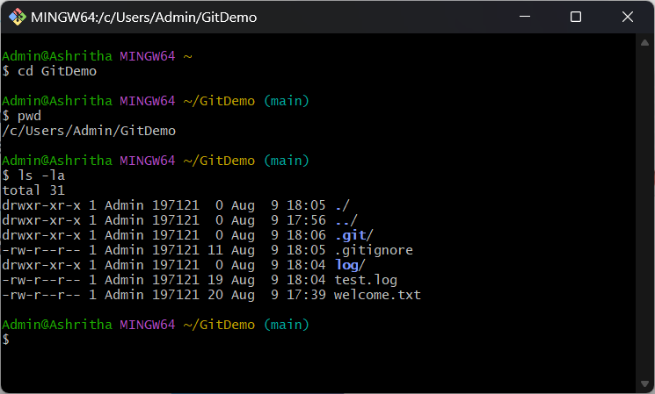

### Step 2: Create a new branch & switch to it

Create a branch named GitNewBranch, list branches, and switch to the new branch.

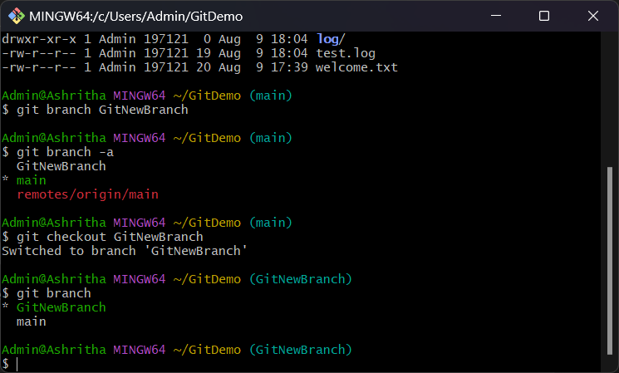

### Step 3: Add files in the new branch

Create two new files in the GitNewBranch branch.

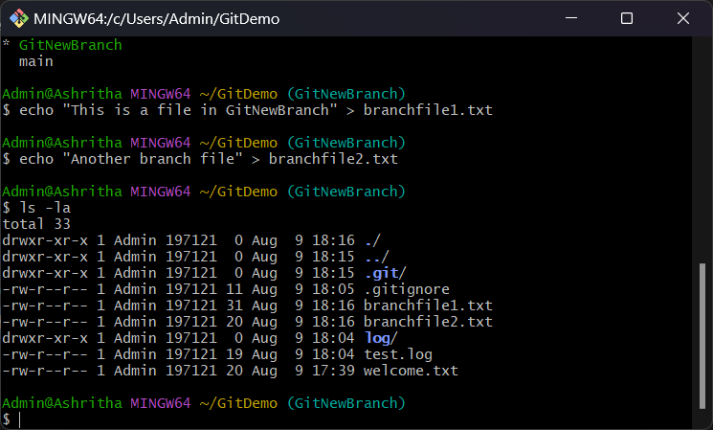

### Step 4: Stage and commit the files

Add the files to staging and commit them.

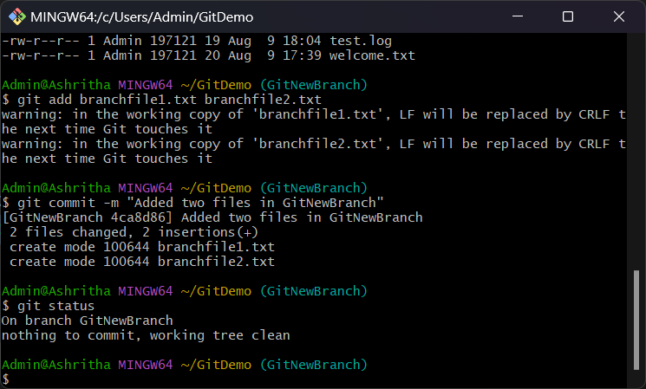

### Step 5: Attempt to delete branch & push

The branch could not be deleted as it is currently checked out. Pushing failed because no upstream branch was set.

